Access Information News
The Week’s News In Access Information

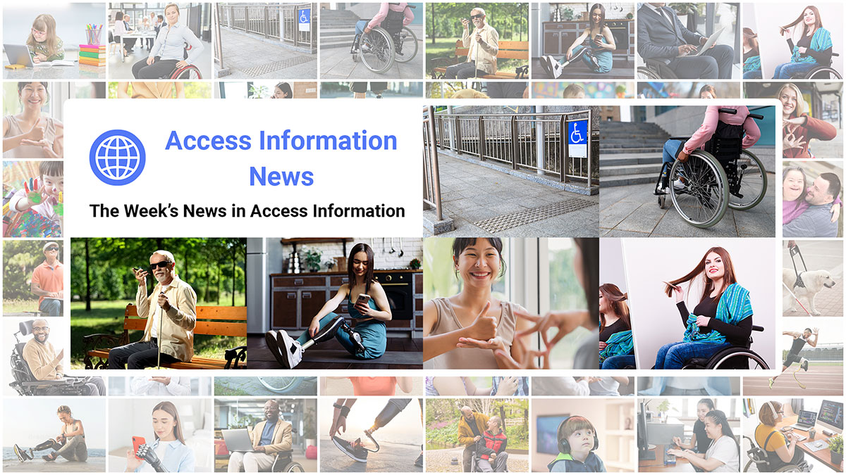

Readership: 43,000 + / week.
Frequency: Weekly on Mondays at 6:00 AM ET.
Most Recent Issues: https://accessinformationnews.com/#new
Subscribe: https://accessinformationnews.com/subscribe
Website: https://accessinformationnews.com
Free Link Tracking: https://accessinformationnews.com/analytics
Sponsorship Information: https://accessinformationnews.com/sponsor
Advertiser Information: https://accessinformationnews.com/advertise

About The Publication: Founded in 2022, Access Information News is the world’s leading not-for-profit access information publication that reaches over 43,000 blind, low vision, deaf, hard of hearing, deafblind, neurodivergent and/or disabled professionals, educators and enthusiasts, all over the world, each week.

1.) Key Newsletter Statistics: Current Subscribers: 43,000 +. Open Rate: 47%. Click Rate: 34%. Bounce Rate: 1.2%. Ad CTRs: 2-12%. (Averages. Last 12 months.) For verification of our stated subscriber counts, please visit our Subscriber Count Screen Shots section.

2.) Sponsorship Package Cost: $200 / month. While packages last. No obligation. Cancel anytime.

Sponsorship Package Cost Breakdown: As a not-for-profit publication, Access Information News charges Sponsors only $50 / month per 10,000 readers served. This fixed cost keeps the publication running as it grows while allowing businesses and organizations to reach an exclusive and highly engaged audience within the access information sector at one of the most cost-effective rates available in digital media today.

3.) Benefits All Sponsors Receive:

- One (1) Sponsor Profile on the Access Information News website.
- One (1) Sponsor Profile in each weekly newsletter.
- One (1) Sponsor Wall Brand Advertisement on the Access Information News home page.
- One (1) Sponsor Wall Brand Advertisement in each weekly newsletter.
- One (1) Classified Advertisement in each weekly newsletter.
- 50% Discount on all Sponsored News Article Advertisements.
- Membership in the PWD Media Co-op for the duration of your sponsorship.
- Free link tracking.
- Permanent SEO benefits.
- Gratitude from over 43,000 access information subscribers for keeping Access Information News free to read.

4.) Availability: As a not-for-profit publication Access Information News offers only 24 Sponsorship Packages at any given time. All Sponsorship Packages are offered on a first-come, first-serve basis. Check availability here. If you would like to become a Sponsor but there are no Sponsorship Packages currently available, you can join the waiting list by sending an email to sponsorships@accessinformationnews.com.

5.) Secure A Package:

A.) Paying Monthly: Register and pay here.

You Will Receive: All of the benefits listed above.
➕︎ Zero (0) Free Featured Advertisement credits per month.

Additional Benefits for Paying Quarterly or Annually:

B.) Paying Quarterly: Register and pay here.

You Will Receive: All of the benefits listed above.
➕︎ One (1) Free Featured Advertisement credit per quarter. ($200 value.)

C.) Paying Annually: Register and pay here.

You Will Receive: All of the benefits listed above.
➕︎ Five (5) Free Featured Advertisement credits per year. ($1,000 value.)

6.) More Information:

➜︎ About Access Information News
➜︎ Sponsorship Packages
➜︎ One Time Advertisements
➜︎ List of Current Sponsors

7.) Contact:

Aaron Di Blasi, PMP



“The greatest barrier to accessibility is indifference.” 💡

PR Director (2024-Present)
AT-Newswire
Access Technology's Digital Newswire
https://at-newswire.com 🌐

Publisher (2024-Present)
AI-Weekly
The Week's News in Artificial Intelligence
https://ai-weekly.ai 🌐

Publisher (2022-Present)
Access Information News
The Week's News in Access Information
https://accessinformationnews.com 🌐

Publisher (2020-Present)
Top Tech Tidbits
The Week's News in Access Technology
https://toptechtidbits.com 🌐

Sr. Project Management Professional (2006-Present)
Mind Vault Solutions, Ltd.
https://mvsltd.com 🌐

Certified:
Digital Marketing Associate, Meta Certified (2022 - Present)
Social Marketing Professional, Hootsuite Certified (2020 - Present)
Email Marketing Professional, Constant Contact Certified (2019 - Present)

Specializing in:
Digital Strategy and Content Marketing
Social Media Advertising
Online Fundraising
ADA, WCAG and Section 508 Compliance

Website: https://mvsltd.com 🌐
Email: ad@mvsltd.com 📧
Toll Free: +1 (855) 578-6660📱️

Schedule A Meeting: https://calendly.com/aarondiblasi
News: https://mvsltd.com/news
Services: https://mvsltd.com/services
Testimonials: https://mvsltd.com/testimonials
Facebook: https://mvsltd.com/facebook
X (Formerly Twitter): https://mvsltd.com/x
LinkedIn: https://mvsltd.com/linkedin
Instagram: https://mvsltd.com/instagram
YouTube: https://mvsltd.com/youtube
Google: https://mvsltd.com/google

